ISO 20022

Charges Management

Message Definition Report Part 1

Approved by the Payments SEG on 04 October 2021

This document provides information about the use of the messages for Charges Management

October 2021

Table of Contents

Table of Contents 2

1 Introduction 5

1.1 Terms and Definitions 5

1.2 Abbreviations and Acronyms 5

1.3 Document Scope and Objectives 5

1.4 References 6

2 Scope and Functionality 7

2.1 Background 7

2.2 Scope 7

2.3 Groups of Message Definitions and Functionality 7

3 BusinessRoles and Participants 9

3.1 Participants and BusinessRoles Definitions 9

3.2 BusinessRoles and Participants Table 10

4 BusinessProcess Description 11

5 Description of BusinessActivities 12

5.1 Charges Payment Notification 12

5.2 Charges Payment Request 13

6 BusinessTransactions 14

6.1 Charges Payment Notification 14

6.2 Charges Payment Request 14

7 Business Examples 15

7.1 ChargesPaymentNotification camt.105.001 15

7.2 ChargesPaymentRequest camt.106.001 16

8 Revision Record 18

Preliminary Note

The Message Definition Report (MDR) is made of three parts:

MDR Part 1

This describes the contextual background required to understand the functionality of the proposed message set. Part 1 is produced by the submitting organisation that developed or maintained the message set in line with an MDR Part 1 template provided by the ISO 20022 Registration Authority (RA) on [www.iso20022.org](http://www.iso20022.org).

MDR Part 2

This is the detailed description of each message definition of the message set. Part 2 is produced by the RA using the model developed by the submitting organisation.

MDR Part 3

This is an extract if the ISO 20022 Business Model describing the business concepts used in the message set. Part 2 is an Excel document produced by the RA.

# Introduction

## Terms and Definitions

The following terms are reserved words defined in ISO 20022 Edition 2013 – Part1. When used in this document, the UpperCamelCase notation is followed.

| Term | Definition |
| --- | --- |
| BusinessRole | Functional role played by a business actor in a particular BusinessProcess or BusinessTransaction. |
| Participant | Involvement of a BusinessRole in a BusinessTransaction. |
| BusinessProcess | Definition of the business activities undertaken by BusinessRoles within a BusinessArea whereby each BusinessProcess fulfils one type of business activity and whereby a BusinessProcess may include and extend other BusinessProcesses. |
| BusinessTransaction | Particular solution that meets the communication requirements and the interaction requirements of a particular BusinessProcess and BusinessArea. |
| MessageDefinition | Formal description of the structure of a message instance. |

1. When a MessageDefinition or message identifier is specified, it should include the variant and version number. However, in this document (except in the business examples section, if present), variant and version numbers are not included. In order to know the correct variant and version number for a MessageDefinition, the related Message Definition Report Part 2 document should be consulted.

## Abbreviations and Acronyms

The following is a list of abbreviations and acronyms used in the document.

| Abbreviation/Acronyms | Definition |
| --- | --- |
| camt | ISO 20022 Cash Management business area |

## Document Scope and Objectives

This document is the first part of the Message Definition Report (MDR) that describes the BusinessTransactions and underlying message set. For the sake of completeness, the document may also describe BusinessActivities that are not in the scope of the business processes covered in this document.

This document describes the following:

* the BusinessProcess scope
* the BusinessRoles involved in these BusinessProcesses

The main objectives of this document are as follows:

* to provide information about the messages that support the business processes
* to explain the BusinessProcesses and BusinessActivities these messages have addressed
* to give a high level description of BusinessProcesses and the associated BusinessRoles
* to document the BusinessTransactions
* to provide business examples

The messages definitions are specified in Message Definition Report Part 2.

## References

| Document | Version | Date | Author |
| --- | --- | --- | --- |
| ISO20022BJ_SWIFT_ChequesCharges_v1.doc | 1.0 | 2020-07-03 | SWIFT |
| ISO20022_MDRPart1_ExceptionsAndInvestigations_2019_2020_v2.docx | 2.0 | 2020-01-09 | SWIFT |

# Scope and Functionality

## Background

This Message Definition Report covers a set of two message definitions developed by SWIFT in close collaboration with payments market infrastructure and cash service providers and approved by the Payments Standards Evaluation Group (SEG) on 4 October 2021. These messages are specifically designed to support charge management.

## Scope

The charge management messages facilitates the account servicing institution to notify and request charges payment.



## Groups of Message Definitions and Functionality

1. These messages are to be used with the ISO 20022 Business Application Header (head.001). The schema and more information about the Business Application Header (BAH) can be found on the www.iso20022.org web site

### Groups

The messages in this message set cover charge management.

#### Charge Management

| MessageDefinition | Message Identifier |
| --- | --- |
| ChargesPaymentNotification | camt.105 |
| ChargesPaymentRequest | camt.106 |

### Related Messages

ChargesPaymentRequest is used to request charges for the cash management initiation and case management workflow.

| MessageDefinition | Message Identifier |
| --- | --- |
| CustomerPaymentCancellationRequest | camt.055 |
| FIToFIPaymentCancellationRequest | camt.056 |
| RequestToModifyPayment | camt.087 |
| ClaimNonReceipt | camt.027 |
| UnableToApply | camt.026 |
| ResolutionOfInvestigation | camt.029 |
| NotificationOfCaseAssignment | camt.030 |
| RequestForDuplicate | camt.033 |
| Duplicate | camt.034 |
| RejectInvestigation | camt.031 |
| CancelCaseAssignment | camt.032 |
| CaseStatusReportRequest | camt.038 |
| CaseStatusReport | camt.039 |
| DebitAuthorisationRequest | camt.037 |
| DebitAuthorisationResponse | camt.036 |
| AdditionalPaymentInformation | camt.028 |
| ProprietaryFormatInvestigation | camt.035 |

### Functionality

See Message Definition Report Part 2 for the message formats.

# BusinessRoles and Participants

A BusinessRole represents an entity (or a class of entities) of the real world, physical or legal, a person, a group of persons, a corporation. Examples of BusinessRoles: “Financial Institution”, “Automated Clearing House”, “Central Securities Depository”.

A Participant is a functional role performed by a BusinessRole in a particular BusinessProcess or BusinessTransaction. Examples of Participants: the “user” of a system, “debtor”, “creditor”, “investor”.

The relationship between BusinessRoles and Participants is many-to-many. One BusinessRole can be involved as different Participants at different moments in time or at the same time. Examples of BusinessRoles: "user", "debtor”, "creditor", "investor". Different BusinessRoles can be involved as the same Participant.

In the context of Charge Management the high-level BusinessRoles and typical Participants can be represented as follows:

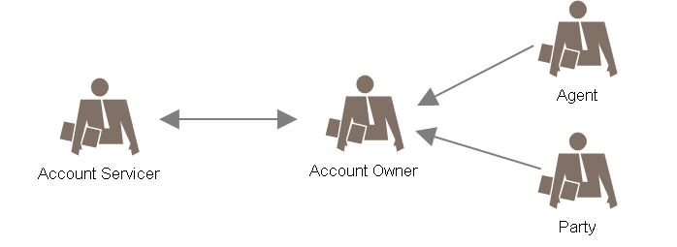

## Participants and BusinessRoles Definitions

Participants

| Description | Definition |
| --- | --- |
| Account Servicer | Agent, which can be a financial institution or a service provider, that provides account services.  Also named Account Servicing Institution |
| Account Owner | Party that legally owns the account with the account servicer. |

Business Roles

| Description | Definition |
| --- | --- |
| Agent | Organisation established primarily to provide financial services to the account owners.  An agent could also be the owner of an account with another account servicing institution |
| Party | Non-financial institution (organisation or person), owns an account with the account servicing institution |

## BusinessRoles and Participants Table

|  | Participant | |
| --- | --- | --- |
| BusinessRole | Account Servicer | Account Owner |
| Agent | X | X |
| Party |  | X |

# BusinessProcess Description

This diagram represents the high level BusinessProcesses.

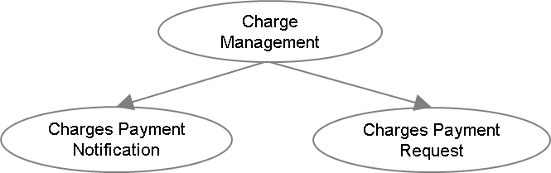

Charges Payment Notification

| Item | Description |
| --- | --- |
| Definition | The account owner is notified by the account servicing institution about the charges, interest or other adjustments which have been debited or credited which are previously unknown to the account owner. |
| Trigger | Charges, interest or other adjustment payments |
| Pre-conditions | The charges, interest or other adjustments have been debited or credited to the account owner's account |
| Post-conditions | Successful notification of charges, interest or other adjustment payments |
| Role | Account servicing institution; account owner (financial institution or customer) |

Charges Payment Request

| Item | Description |
| --- | --- |
| Definition | The account servicing institution requests the account owner (financial institution) for the payment of charges, interest and other expenses that are previously unknown to the account owner. |
| Trigger | Charges, interest or other adjustment payments |
| Pre-conditions | Chargeable service availed by the account owner |
| Post-conditions | Successful charges, interest or other adjustment payments |
| Role | Account servicing institution, account owner (financial institution) |

# Description of BusinessActivities

This section presents the different BusinessActivities within each BusinessProcess. The BusinessActivities of a process are described with activity diagrams.

Legend

| Symbol | Name | Definition |
| --- | --- | --- |
|  | Start Point | Shows where the lifecycle of the business process commences. |
|  | End Point | Shows where the lifecycle of the business process may ends. |
|  | Lozenge (or diamond) | Indicates that a choice between several actions can be made. |
|  | Bar | Indicates that several actions are initiated in parallel. |

## Charges Payment Notification

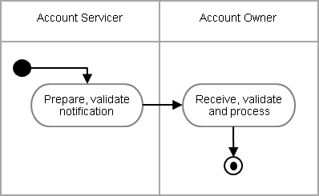

| Step | Description | Initiator |
| --- | --- | --- |
| Prepare, validate notification | The validated notification sent to the account owner. A single message can contain one or more sets of charges and payment details. . | Account Servicer |
| Receive, validate and process | The notification received, validated and processed. | Account Owner |

## Charges Payment Request

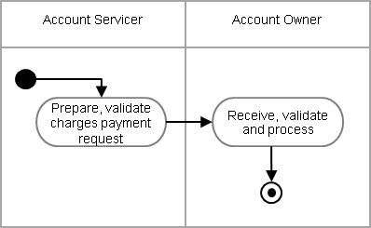

| Step | Description | Initiator |
| --- | --- | --- |
| Prepare, validate charges payment request | The validated charges payment request sent to the account owner. A single message can contain one or more sets of charges and payment details. | Account Servicer |
| Receive, validate and process | The charges payment message received, validated and processed. | Account Owner |

# BusinessTransactions

This section describes the message flows based on the activity diagrams documented above. It shows the typical exchanges of information in the context of a BusinessTransaction.

## Charges Payment Notification

The account serving institution sends a ChargesPaymentNotification message to the account owner. These charges, interest or other adjustment details are previously unknown to the account owner. A single notification message can have one or many sets of charges information.

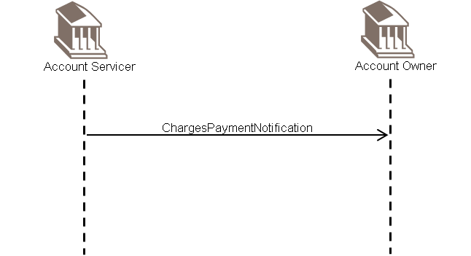

## Charges Payment Request

The account serving institution sends a ChargesPaymentRequest message to the account owner. These charges, interest or other expenses are previously unknown to the account owner. A single charges payment request message can have one or many sets of charges information.

The charges payment request will be addressed through the Exception and Investigations message set.

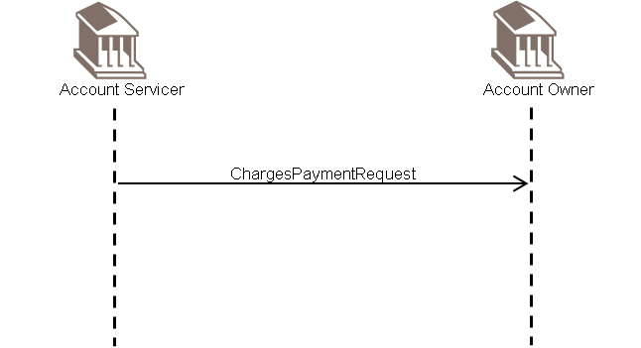

# Business Examples

This section describes business examples of the use of the various MessageDefinitions.

## ChargesPaymentNotification camt.105.001

Description

A ChargesPaymentNotification message is sent by an account service provider to the account owner, to advise charges that are previously unknown to the account owner.

Message Instance

|  |  |
| --- | --- |
| XML | Comment |
| <ChrgsPmtNtfctn> | Charges Payment Notification |
| <GrpHdr> | Group Header |
| <MsgId>00301</MsgId> | Message Identification |
| <CreDtTm>2001-12-17T09:30:00</CreDtTm> | Creation Date Time |
| <NbOfChrgsRcrds>1</NbOfChrgsRcrds> | Number Of Charges Records |
| </GrpHdr> |  |
| <Chrgs> | Charges (one repetition) |
| <UndrlygTx> | Underlying Transaction |
| <MsgId>AAAA100628-123v</MsgId> | Message Identification |
| <ChqNb>210092979</ChqNb> | Cheque Number |
| </UndrlygTx> |  |
| <Amt Ccy="GBP">10</Amt> | Amount |
| <CdtDbtInd>DBIT</CdtDbtInd> | Credit Debit Indicator |
| <DbtrAgt> |  |
| <FinInstnId> |  |
| <BICFI>PEFIUS33LAX</BICFI> | Debtor Agent |
| </FinInstnId> |  |
| </DbtrAgt> |  |
| <ChrgsAcct> |  |
| <Id> |  |
| <IBAN>BE30001216371411</IBAN> | Charges Account |
| </Id> |  |
| </ChrgsAcct> |  |
| <Tp> |  |
| <Cd>COMM</Cd> | Commission |
| </Tp> |  |
| </Chrgs> |  |
| </ChrgsPmtNtfctn> |  |

## ChargesPaymentRequest camt.106.001

Description

A ChargesPaymentRequest message is sent by an account service provider to the account owner, to request charges payment that are previously unknown to the account owner.

Message Instance

|  |  |
| --- | --- |
| XML | Comment |
| <ChrgsPmtReq> | Charges Payment Request |
| <GrpHdr> | Group Header |
| <MsgId>00242</MsgId> | Message Identification |
| <CreDtTm>2001-12-17T09:30:00</CreDtTm> | Creation Date Time |
| <NbOfChrgsRcrds>1</NbOfChrgsRcrds> | Number Of Charges Records |
| </GrpHdr> |  |
| <Chrgs> | Charges |
| <UndrlygTx> | Underlying Transaction |
| <MsgId>AAAA102624-769</MsgId> | Message Identification |
| </UndrlygTx> |  |
| <Amt Ccy="GBP">10</Amt> | Amount |
| <DbtrAgt> |  |
| <FinInstnId> |  |
| <BICFI>PEFIUS45LAX</BICFI> | Debtor Agent |
| </FinInstnId> |  |
| </DbtrAgt> |  |
| <Tp> |  |
| <Cd>BRKF</Cd> | Brokerage Fee |
| </Tp> |  |
| </Chrgs> |  |
| </ChrgsPmtReq> |  |

# Revision Record

|  |  |  |  |  |
| --- | --- | --- | --- | --- |
| Revision | Date | Author | Description | Sections affected |
|  |  |  |  |  |
|  |  |  |  |  |
|  |  |  |  |  |
|  |  |  |  |  |
|  |  |  |  |  |
|  |  |  |  |  |

Disclaimer:

Although the Registration Authority has used all reasonable efforts to ensure accuracy of the contents of the iso20022.org website and the information published thereon, the Registration Authority assumes no liability whatsoever for any inadvertent errors or omissions that may appear thereon. Moreover, the information is provided on an "as is" basis. The Registration Authority disclaims all warranties and conditions, either express or implied, including but not limited to implied warranties of merchantability, title, non-infringement and fitness for a particular purpose.

The Registration Authority shall not be liable for any direct, indirect, special or consequential damages arising out of the use of the information published on the iso20022.org website, even if the Registration Authority has been advised of the possibility of such damages.

Intellectual Property Rights:

The ISO 20022 MessageDefinitions described in this document were contributed by SWIFT. The ISO 20022 IPR policy is available at www.ISO20022.org > About ISO 20022 > Intellectual Property Rights.